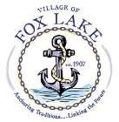

PUBLIC NOTICE

THE FOX LAKE POLICE AND FIRE COMMISSION BOARD MEETING REGULARLY SCHEDULED FOR TUESDAY, APRIL 5th, 2022, HAS BEEN CANCELLED.

President Michael Trinski
Fox Lake Police and Fire Commission
66 Thillen Drive
Fox Lake, IL 60020

4-1-2022

